Lawrence Ball

1806560

Software Engineering Logbook

Table of Contents

Logbook 2

Week Commencing 23/09/2019 (Week 1) 2

Week Commencing 30/09/2019 (Week 2) 3

User Stories 3

Patient 3

Nurse Practioner 3

Matron 4

IT Staff 4

Management 4

Week Commencing 07/10/2019 (Week 3) 4

Week Commencing 14/09/2019 (Week 4) 5

Week Commencing 24/10/2019 (Week 5) 6

Week Commencing 28/10/2019 (Week 6) 8

Week Commencing 04/11/2019 (Week 7) 8

Week Commencing 11/11/2019 (Week 8) 9

# Logbook

## Week Commencing 23/09/2019 (Week 1)

I joined a group of students whom I am familiar with and some that I am not for the assignment that has been issued to us. One of the requirements for this assignment is to keep a logbook of each week documenting the events so that I and others can track my progress within the group. First and foremost, I thought it were necessary to have some recognisable faces and some that are not so that I felt comfortable enough to voice my opinions and ideas however I get the opportunity to hear ideas from a fresh new prospective.

Having gotten introduction done, we moved onto the assignment. We were tasked with coming up with a new version of a patient monitoring system for a hospital. This system would need to govern over 4 different areas.

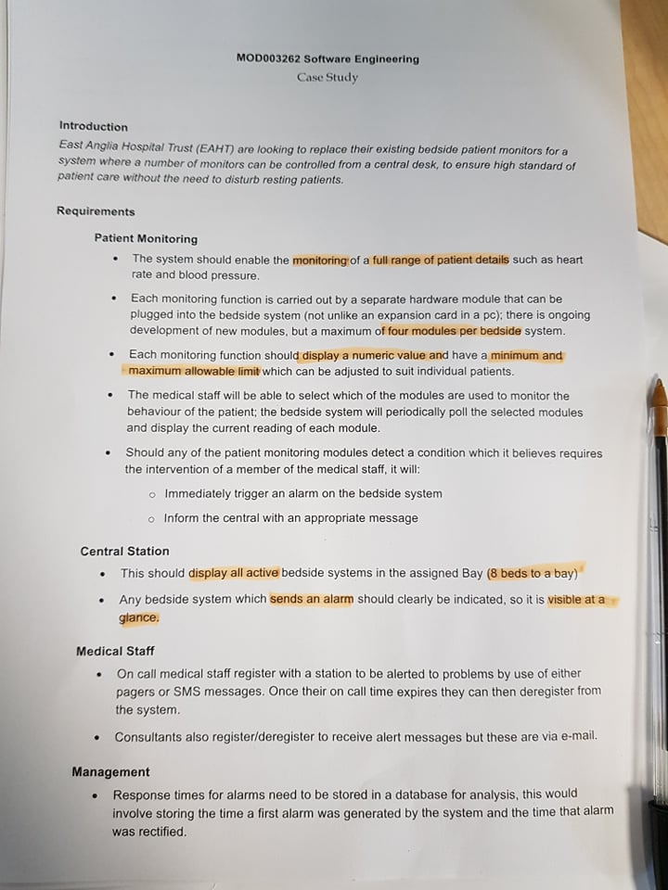

The group decided on brainstorming what the patient monitoring system would include, who would have access, what the repercussions are etc…

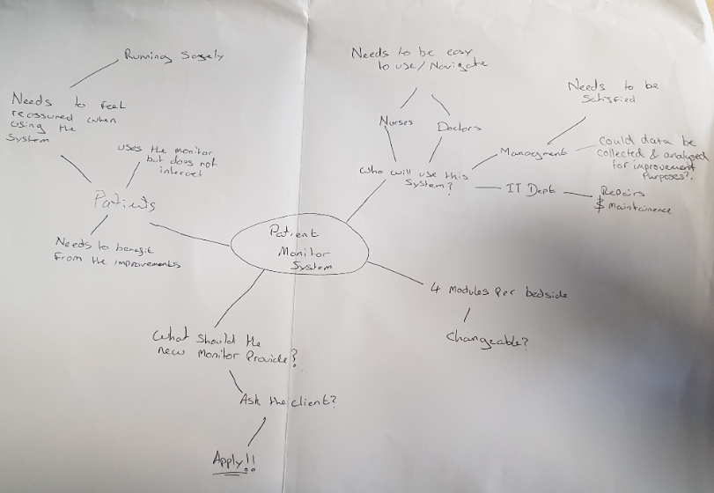

Currently the group is spending some time to come up with some more detailed ideas on a more independent level before reconvening so that we can push forward towards the design section quicker.

## Week Commencing 30/09/2019 (Week 2)

User Stories are the “I am a ….. and I want …..” based testimony by doctors, nurses etc. This is to find out what the system should have using the client’s opinions as a reference (see my contribution below). Once me and the other members of the team have collaborated all of our user stories then we pick the best stories and remove all the repeated notions and opinions so we are left with a raw copy that has all of the opinions and testimonies that we can work with.

## User Stories

### Patient

As a patient I want peace of mind that if something were to go wrong, I know that I will receive the help I require. By having this sense of security, I can focus on the injury of illness at hand rather than worry if I will receive help when I need it. I expect nothing less than the best equipment and doctors/nurse at the hospital’s disposable. I speak for all the patients when I say, “I feel more at ease when I have a call nurse button”. I think this is just for a better piece of mind and can help me relax in an already anxious environment.

### Nurse Practioner

As a Nurse Practioner I want my patients to feel safe and well taken care of but also, I would like a system that is easy to navigate to that I can perform my duties as a nurse efficiently too. Should something happen to a patient in my care I would like to know as soon as it happens so I can get to them asap. I would also like the system to be clear about what needs my attention such as “pulse rate declining. Needs immediate attention.”. An alarm telling me who, what, where and when would be perfect.

### Matron

As a Matron I want my staff (nurses) to work as efficiently as possible and by using a system that’s reliable and easy to use, this can be a possibility. I get a lot of patients’ information like injury reports and diagnoses, so knowing that all the patients’ monitoring systems are easy to use and are functioning safely, I can then assign all my nurses to the correct stations. This helps the Paediatricians, Radiographers, Phlebotomists and Orthopaedic staff (and so on) receive the correct patients when a diagnosis is complete. As I mentioned before, this process can be sped up when we do not have to worry about having to figure out how to use the equipment provided which includes the monitoring system.

### IT Staff

As IT staff I want the best service I can offer and to do that I need the best monitoring system in place. By having a system that people who may not be “tech savvy” can utilise with ease, this give us a peace of mind. This is because we will not get multiple requests to come out and help staff at the patients’ bedside understand how to use the old monitoring systems. This frees up the team to work on updates for the new system whenever required and helps us keep the equipment working at the highest expectations and this includes maintaining the alarms on each monitor.

### Management

As a Manager all I want is the patients’ complete faith in our hospital and by them seeing the equipment we use is nothing less than “state of the art”, I can’t see this goal being unattainable. I already have the best staff who are highly trained and the support of the county administrators. The other aspect of my job is health and safety so I would like to analyse the amount of times the patient alarm goes off and the response time so that I can work with the ward staff to help get these times down.

## Week Commencing 07/10/2019 (Week 3)

Wire Frames are useful for bringing the system that we are designing into light and help everyone get an idea as to what the system will look like. This week our lead designer was tasked with coming up with this design however the rest of us had decided to come up with designs of our own to present to the lead designer. This is so He can have plenty of options and we all can come up with a wireframe that we all agree on.

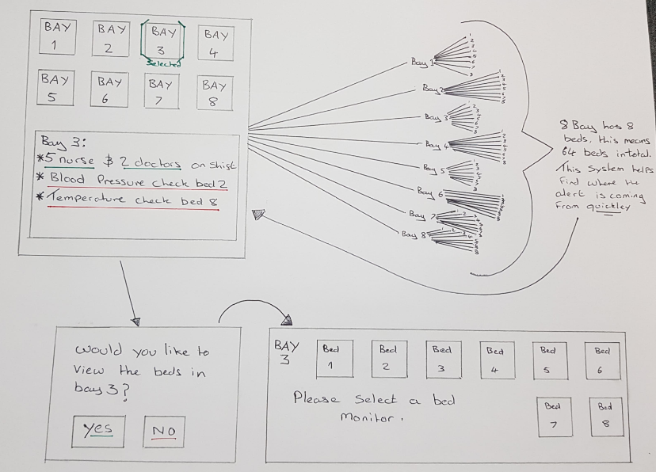

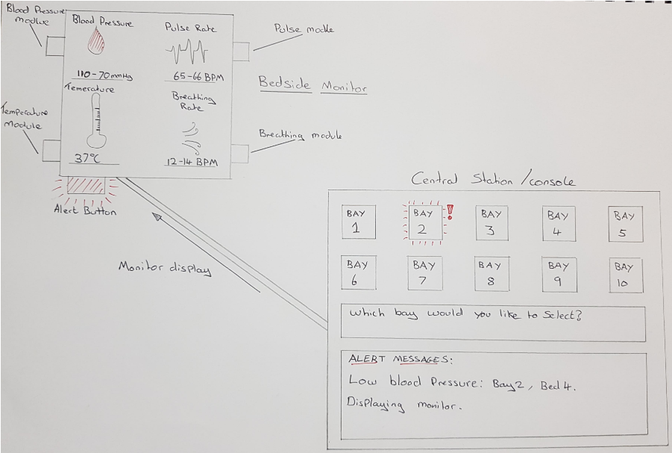

## Week Commencing 14/09/2019 (Week 4)

Having picked the wireframe, everyone was assigned a form to design and build to upload to Github. This is because when all the forms can be saved in one solution and then coded together. I designed the login page and uploaded it to Github, I also noticed that throughout this week, the other forms were being uploaded as the other members completed their assigned forms.

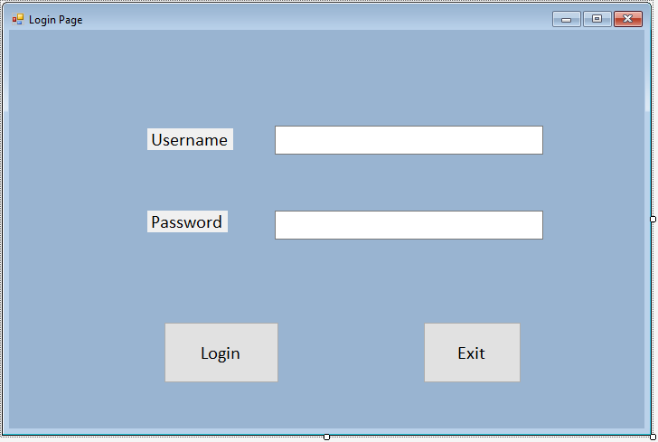.

## Week Commencing 24/10/2019 (Week 5)

During this week my and the team began piecing all the forms that everyone designed together so that it flows better, both visually and mechanically. Using the finalised wireframe as a guide, this process was easy to do.

This feat was accomplished through Github where in team members could colour coordinate the forms and begin the process of organising them in order of which form would be viewed first. For example, the Login page would be first followed by the main page.

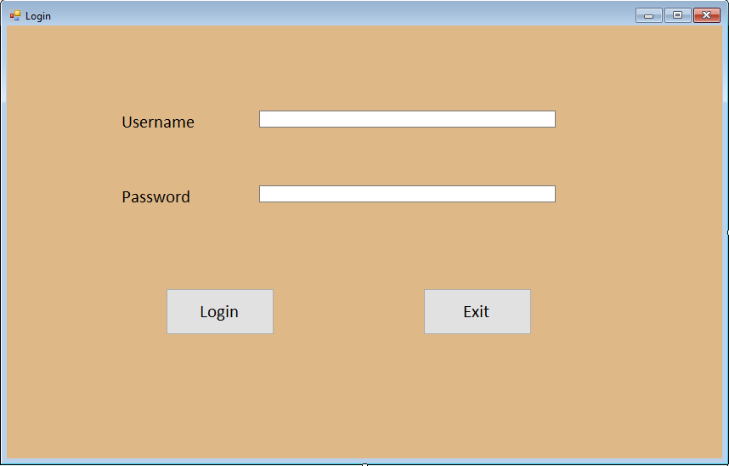

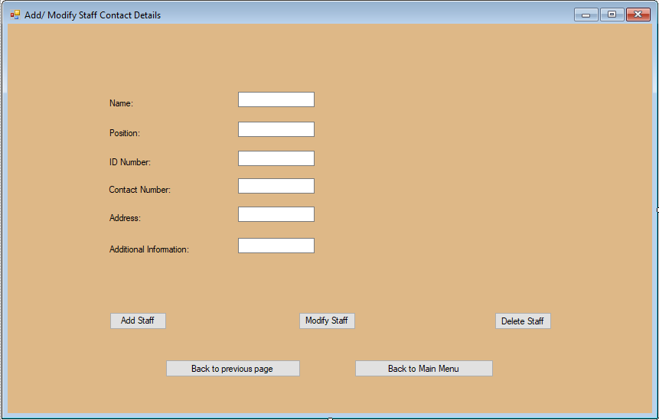

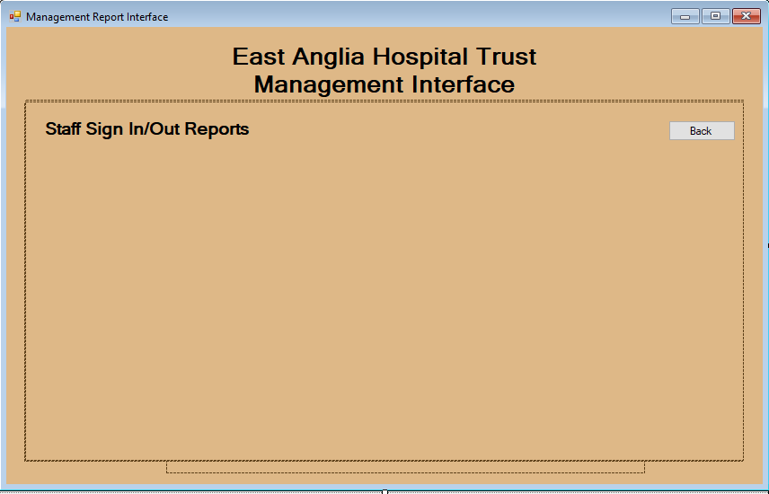

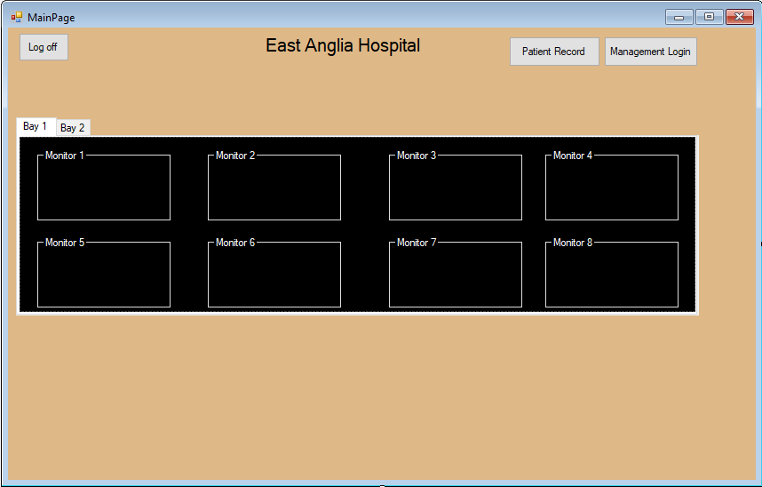

The main area that we focused on this week was building the database. We ended up having roughly 15 entities for the database and even though this worked out nicely and was efficient, we went back through the client’s requirements and it seems we only needed roughly 8 to 10 entities. This is something that would need correct.

## Week Commencing 28/10/2019 (Week 6)

Outside of our usual labs and lectures, the team organised a meeting in the library to iron out some information that was getting lost in translation when messaging each other. It was apparent that we can get around this with a simple face to face meeting.

As per the previous week, we were struggling with how many entities we should have in the database, so we took the time to write up a WEER diagram with everybody’s input. The outcome was very positive because it looks like we can start testing procedure easier now.

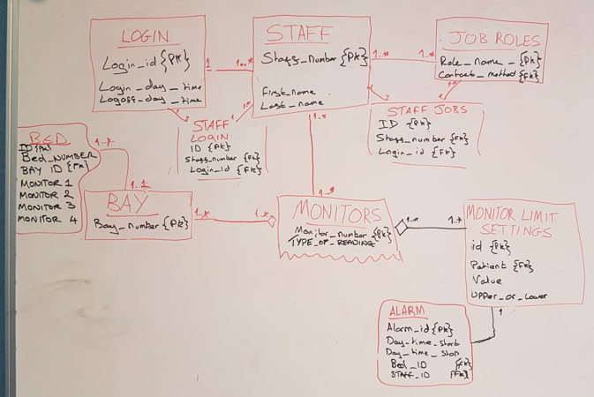

## Week Commencing 04/11/2019 (Week 7)

This week we reconvened outside of out timetabled labs and lectures to talk about moving forward with the coding section and found that things have become quite chaotic with a lack of a plan or structure to things. Going through the previous weeks lectures and the steps taken we have seen that we did not pick a definitive set of user stories. Having found the problem, we have set ourselves the task this week to concentrate on implementing these stories into a class diagram and draw up an activity diagram. As embarrassing as it is to admit, it seems necessary to back track but without this decision to do so, we could have made life much harder for us next week when we focus solely on coding all the forms.

During the session we used the white board provided in the library to brainstorm ideas, draw up beta diagrams and constantly make edits whilst discussing, I have included this picture below.

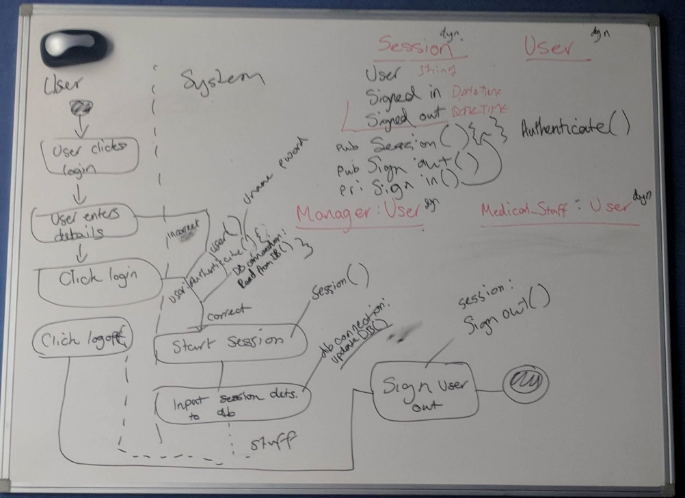

## Week Commencing 11/11/2019 (Week 8)